

SAVEETHA SCHOOL OF ENGINEERING

SAVEETHA INSTITUTE OF MEDICAL AND
TECHNICAL SCIENCES

DEPARTMENT OF COMPUTER SCIENCE AND ENGINEERING

LIST OF EXPERIMENTS

COURSE CODE : CSA4001
COURSE NAME : MANAGEMENT INFORMATION SYSTEM

8 Describe major services (functionality) provided by a hospital's reception. Summary: Hospital Management System is a large system including several subsystems or modules providing variety of functions. Hospital Reception subsystem or module supports some of the many job duties of hospital receptionist. Receptionist schedules patient's appointments and admission to the hospital, collects information from patient upon patient's arrival and/or by phone. For the patient that will stay in the hospital ("inpatient") she or he should have a bed allotted in a ward. Receptionists might also receive patient's payments, record them in a database and provide receipts, file insurance claims and medical reports.

AIM:
To describe the major services provided by a hospital's reception subsystem in a Hospital Management System.

PROCEDURE:
• Scheduling Appointments and Admissions:
The receptionist schedules patient appointments and admissions, either by phone or in person.
• Collecting Patient Information:
The receptionist collects necessary personal and medical information from the patient upon arrival.
• Bed Allotment for Inpatients:
For inpatients, the receptionist assigns a bed in a hospital ward.
• Receiving Payments:
Receptionists may receive patient payments, record them in the system, and issue receipts.
• Insurance Claims and Medical Reports:
They file insurance claims and manage medical reports as required.

OBSERVATION:

USECASE DIAGRAM:
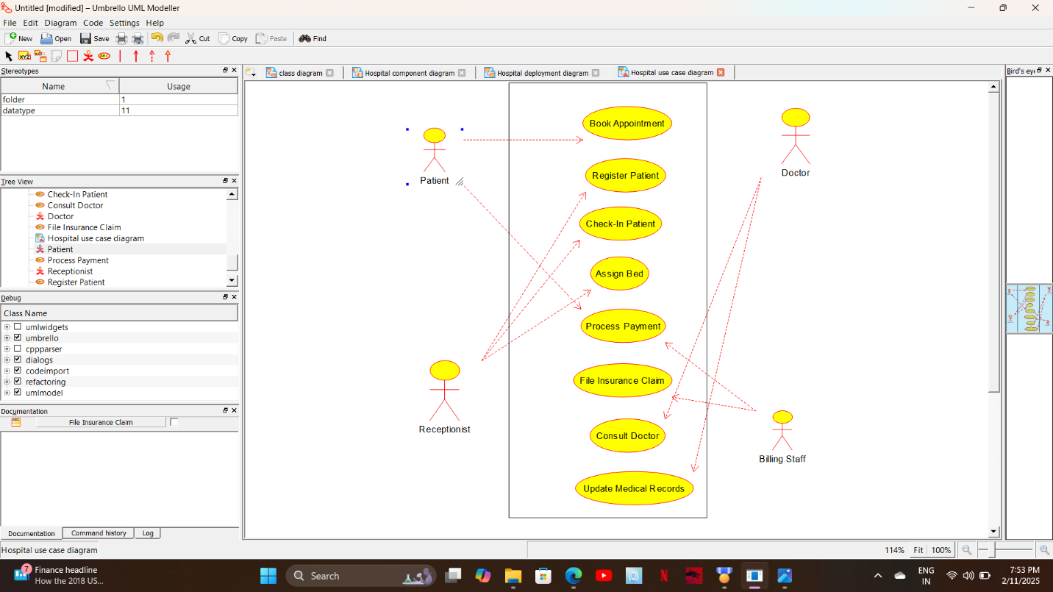

CLASS DIAGRAM:
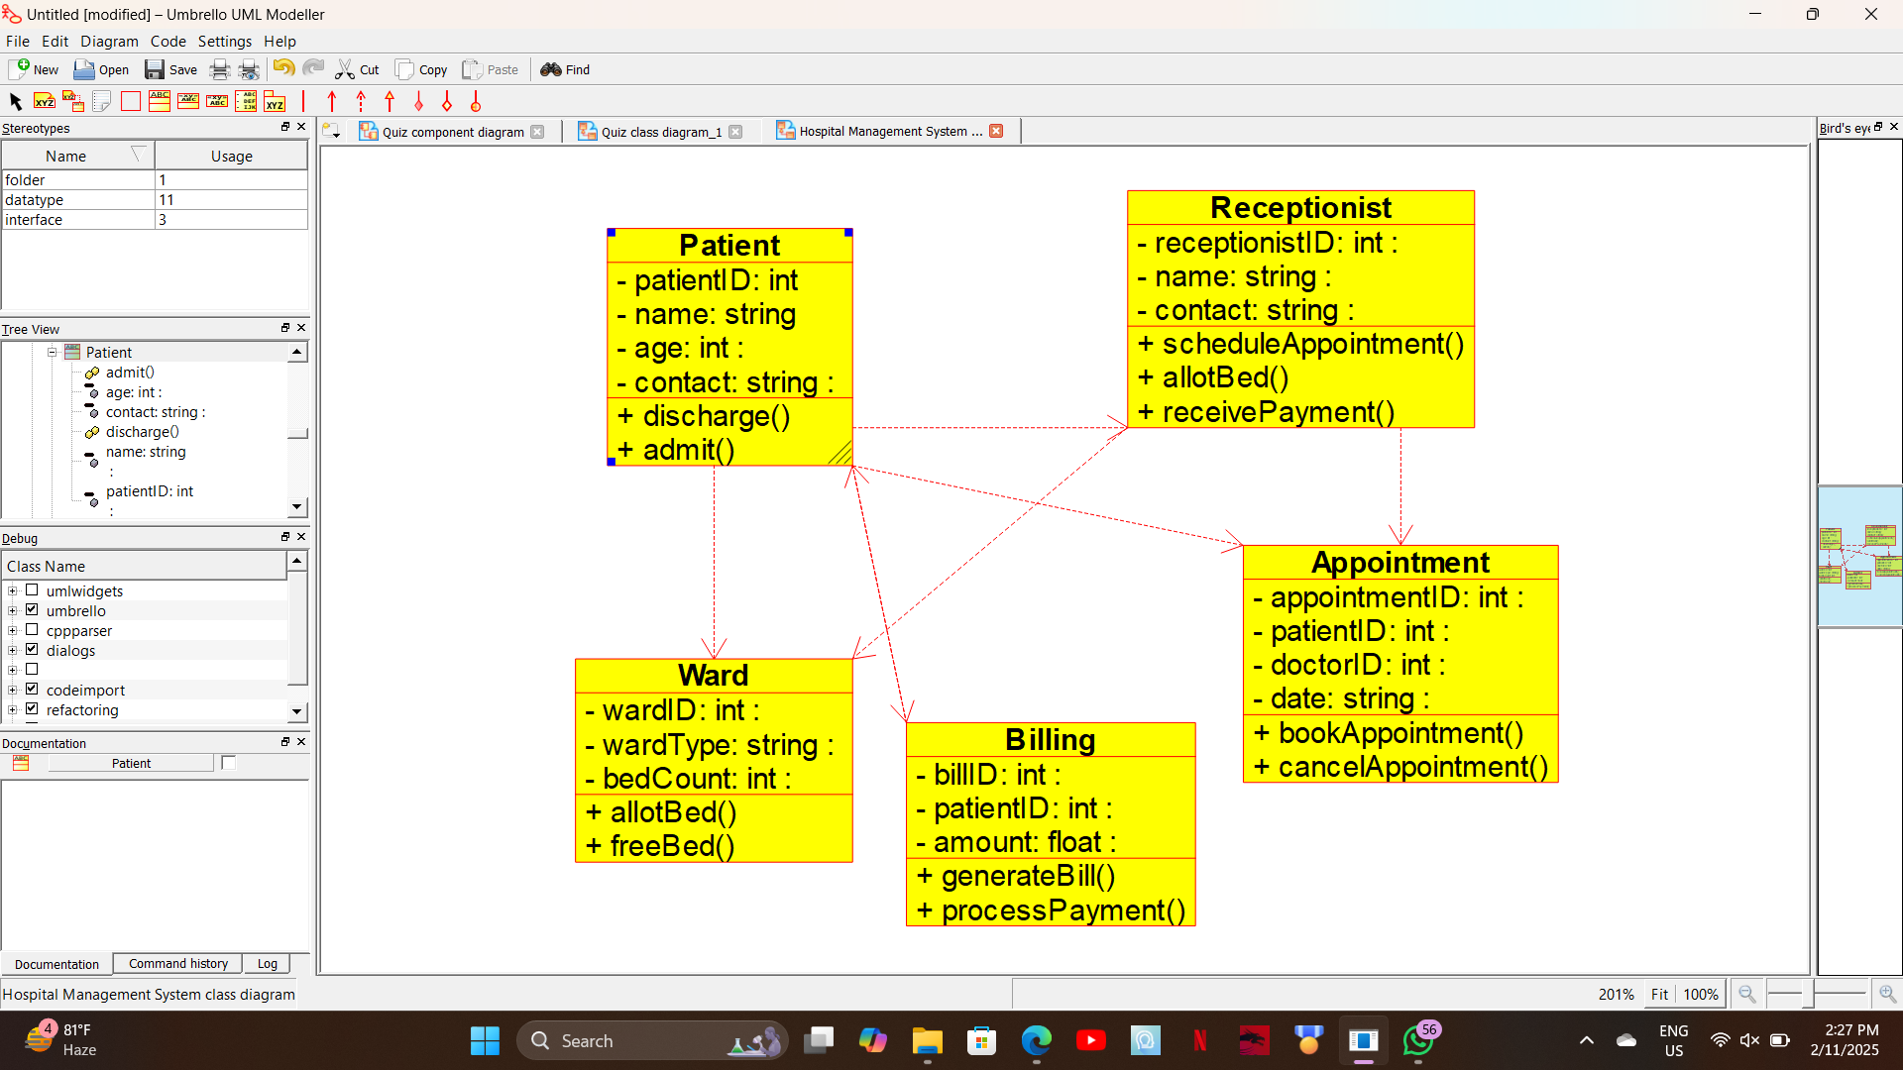
ACTIVITY DIAGRAM:
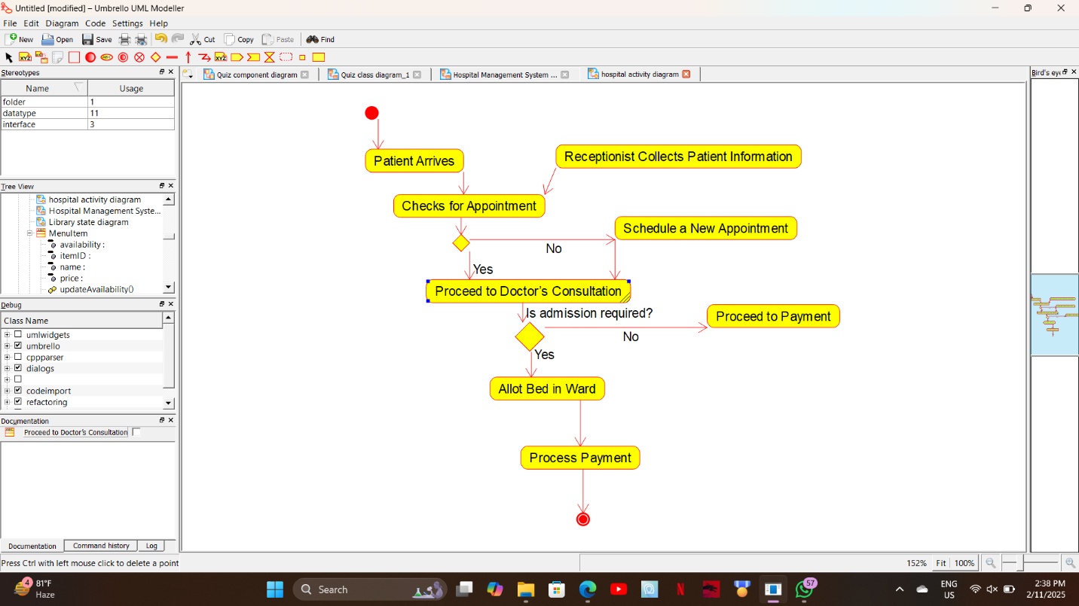

STATE DIAGRAM:
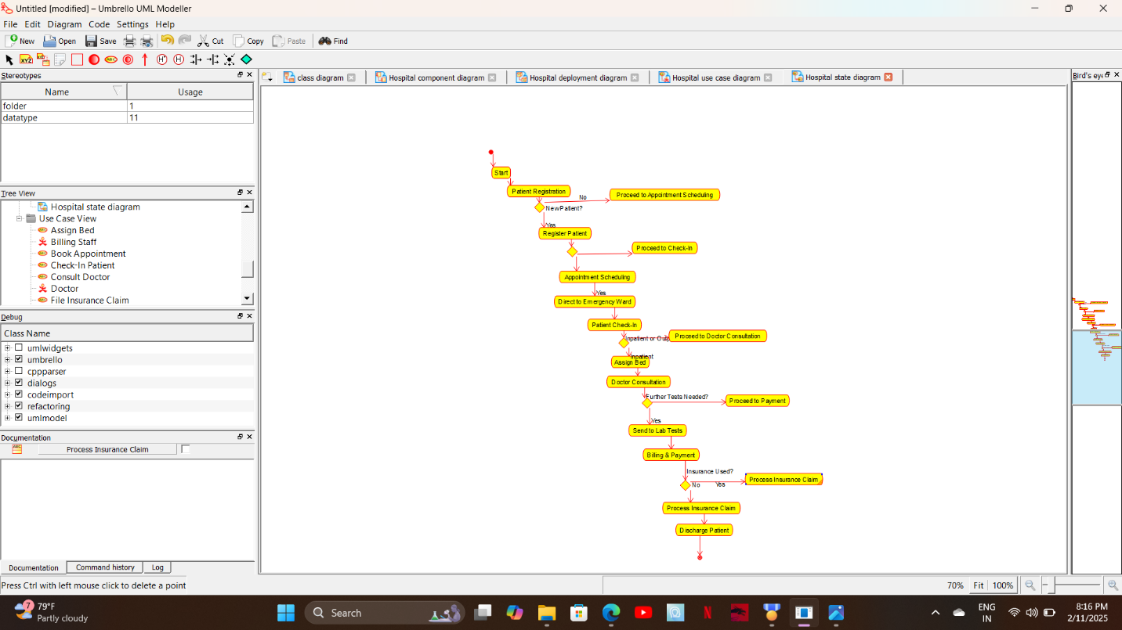

SEQUENCE DIAGRAM:
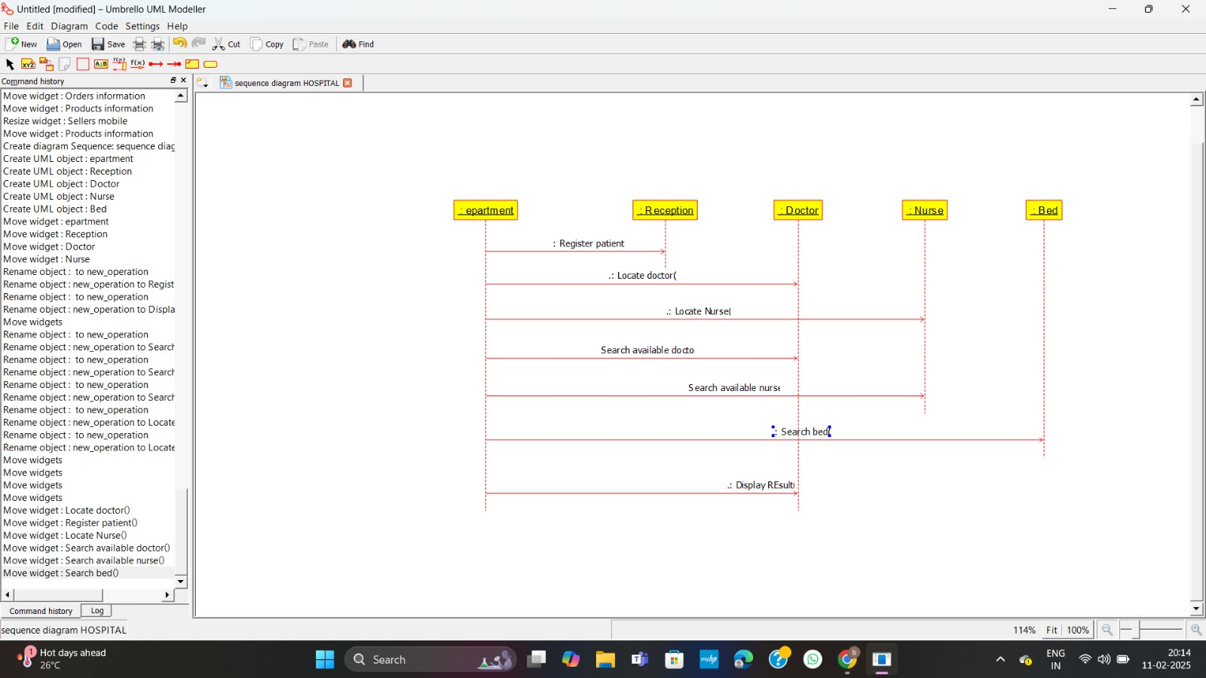

COMPONENT DIAGRAM:
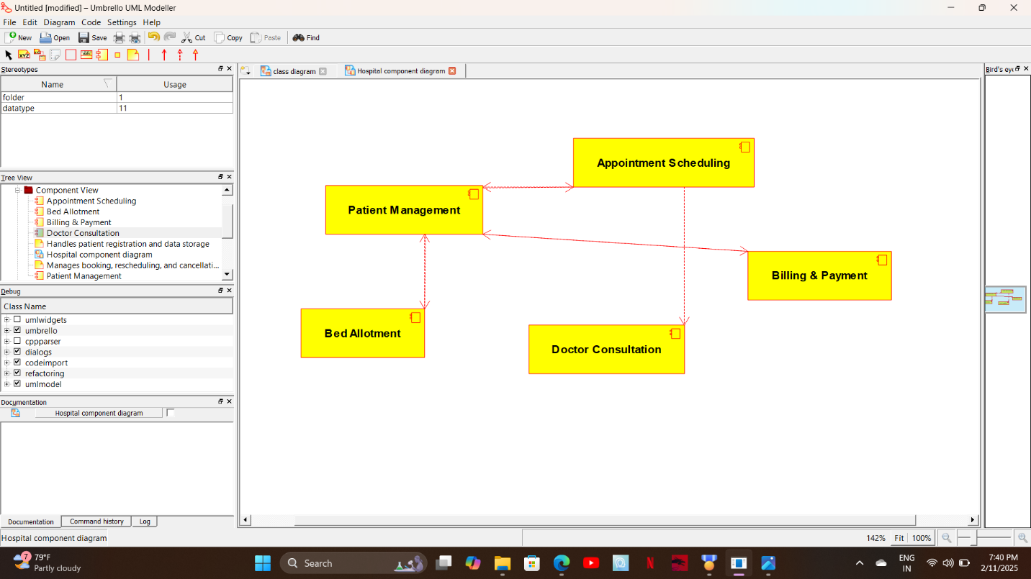

DEPLOYMENT DIAGRAM:
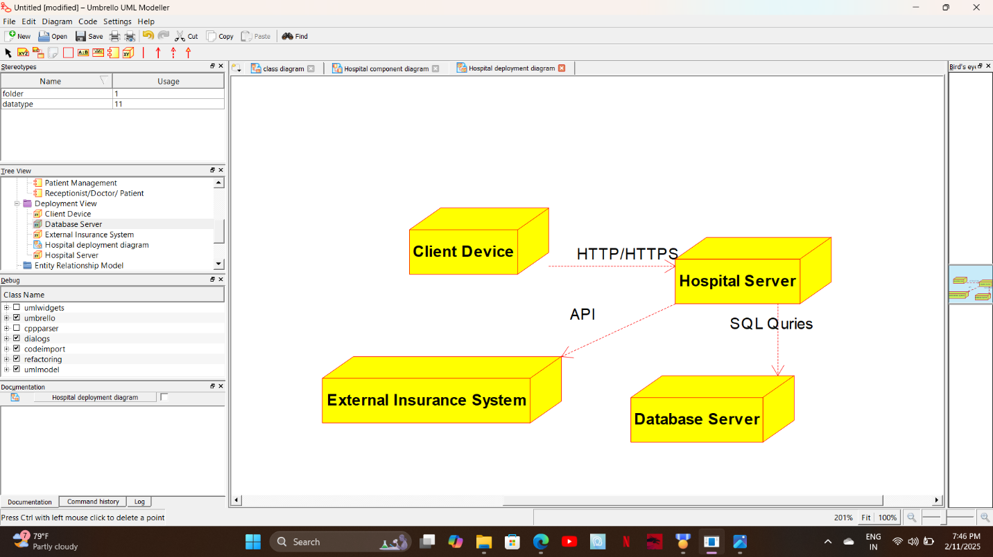

RESULT:

The UML Diagram for the major services provided by the hospital's reception subsystem have been successfully described, outlining the processes of scheduling appointments, collecting patient information, bed allotment for inpatients, receiving payments, and managing insurance claims and medical reports.

